ATHARVA SANTOSH GHAVRE 8
1.A CREATE A SIMPLE CALCULATOR APPLICATIONS USING A SERVLET
Index.html
<!DOCTYPE html>
<html lang=”en”>
<head>
<meta charset=”UTF-8”>
<title>Calculator App</title>
</head>
<body>
<h2>Calculator App</h2>
<form action=”CalculatorServlet” method=”get”>
<label>
Enter First Number:
<input type=”text” name=”txtN1” required>
</label>
<br><br>

<label>
Enter Second Number:
<input type=”text” name=”txtN2” required>
</label>
<br><br>

<p>Select an Operation:</p>
<label><input type=”radio” name=”opr” value=”+” required> Addition</label><br>
<label><input type=”radio” name=”opr” value=”-“> Subtraction</label><br>
<label><input type=”radio” name=”opr” value=”*”> Multiplication</label><br>
<label><input type=”radio” name=”opr” value=”/”> Division</label><br><br>

<input type=”reset” value=”Clear”>
<input type=”submit” value=”Calculate”>
</form>
</body>
</html>

CalculatorServlet.java

Import jakarta.servlet.ServletException;
Import jakarta.servlet.annotation.WebServlet;
Import jakarta.servlet.http.HttpServlet;
Import jakarta.servlet.http.HttpServletRequest;
Import jakarta.servlet.http.HttpServletResponse;
Import java.io.*;

@WebServlet(“/CalculatorServlet”)
Public class CalculatorServlet extends HttpServlet {

@Override
Public void doGet(HttpServletRequest request, HttpServletResponse response)
Throws ServletException, IOException {

Response.setContentType(“text/html;charset=UTF-8”);
PrintWriter out = response.getWriter();

Out.println(“<html><head><title>Calculator Result</title></head><body>”);

Try {
Double n1 = Double.parseDouble(request.getParameter(“txtN1”));
Double n2 = Double.parseDouble(request.getParameter(“txtN2”));
String opr = request.getParameter(“opr”);

Double result = 0;
String operation = “”;

If (opr.equals(“+”)) {
Result = n1 + n2;
Operation = “Addition”;
} else if (opr.equals(“-“)) {
Result = n1 – n2;
Operation = “Subtraction”;
} else if (opr.equals(“*”)) {
Result = n1 * n2;
Operation = “Multiplication”;
} else if (opr.equals(“/”)) {
If (n2 != 0) {
Result = n1 / n2;
Operation = “Division”;
} else {
Out.println(“<h3>Error: Division by zero is not allowed.</h3>”);
Out.println(“</body></html>”);
Return;
}
}

Out.println(“<h2>Operation: “ + operation + “</h2>”);
Out.println(“<h2>Result = “ + result + “</h2>”);
} catch (NumberFormatException e) {
Out.println(“<h3>Error: Please enter valid numbers.</h3>”);
}
Out.println(“</body></html>”);
}
}
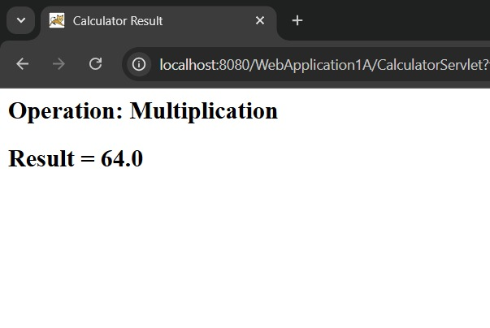
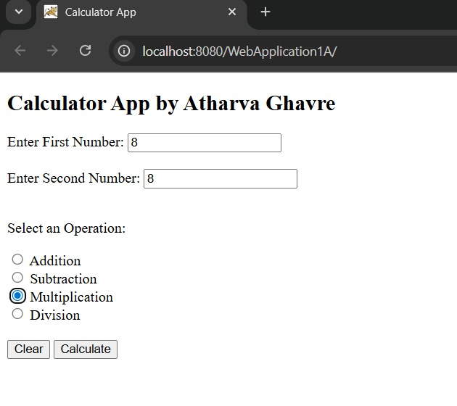
OUTPUT:

1B. Create a servlet for a login page. If the username and password are correct then it says message "Hello <username>" else a message "login failed"

Index.html
<html>
<head>
<title>Login Form</title>
</head>
<body>
<form action=”LoginServlet” method=”post”>
<label for=”txtId”>Enter User ID</label>
<input type=”text” id=”txtId” name=”txtId”><br>

<label for=”txtPass”>Enter Password</label>
<input type=”password” id=”txtPass” name=”txtPass”><br>

<input type=”reset”>
<input type=”submit” value=”Click to Login”>
</form>
</body>
</html>

LoginServlet.java
Import java.io.*;
Import jakarta.servlet.*;
Import jakarta.servlet.http.*;
Import jakarta.servlet.annotation.WebServlet;

@WebServlet(“/LoginServlet”)
Public class LoginServlet extends HttpServlet {

@Override
Public void doPost(HttpServletRequest request, HttpServletResponse response)
Throws ServletException, IOException {

Response.setContentType(“text/html;charset=UTF-8”);
PrintWriter out = response.getWriter();

String uname = request.getParameter(“txtId”); // fixed typo
String upass = request.getParameter(“txtPass”);

Out.println(“<html><head><title>Servlet LoginServlet</title></head>”);

If (“Atharva Ghavre”.equals(uname) && “12345”.equals(upass)) {
Out.println(“<body bgcolor=’blue’>”);
Out.println(“<h1>Welcome !!! “ + uname + “</h1>”);
} else {
Out.println(“<body bgcolor=’red’>”);
Out.println(“<h1>Login Fail !!!</h1>”);
}

Out.println(“</body></html>”);
}
}
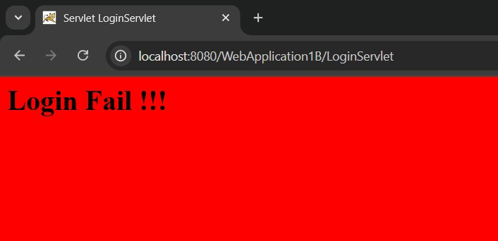
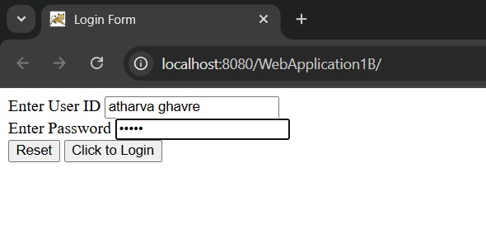
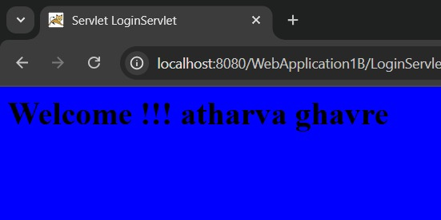
OUTPUT:
1C.Create a registration Servlet in Java using JDBC. Accept the details such as Username, Password, Email, and Country from the user using HTML Form and store the registration details in the database.

Index.html
<html>
<head>
<title>Registration Page</title>
</head>
<body>
<form action="RegisterServlet" method="post">
<h1>Welcome to Registration page by Atharva Ghavre</h1>
Enter User Name<input type="text" name="username"><br>
Enter Password<input type="password" name="password"><br>
Enter Email <input type="text" name="email"><br>
Enter Country<input type="text" name="country"><br>
<input type="reset"><input type="submit" value="REGISTER">
</form>
</body>
</html>

RegisterServlet.java
Import jakarta.servlet.ServletException;
Import jakarta.servlet.annotation.WebServlet;
Import jakarta.servlet.http.HttpServlet;
Import jakarta.servlet.http.HttpServletRequest;
Import jakarta.servlet.http.HttpServletResponse;
Import java.io.*;
Import java.sql.*;

@WebServlet(“/RegisterServlet”)
Public class RegisterServlet extends HttpServlet {

@Override
Public void doPost(HttpServletRequest request, HttpServletResponse response)
Throws ServletException, IOException {

Response.setContentType(“text/html;charset=UTF-8”);
PrintWriter out = response.getWriter();

// Read form parameters
String id = request.getParameter(“username”);
String ps = request.getParameter(“password”);
String em = request.getParameter(“email”);
String co = request.getParameter(“country”);

Try {
// Load Driver
Class.forName(“com.mysql.cj.jdbc.Driver”);

// Connect to Database
Connection con = DriverManager.getConnection(
“jdbc:mysql://localhost:3306/sr”, “root”, “atharva6745”);

// Insert into DB
PreparedStatement pst = con.prepareStatement(“INSERT INTO user VALUES (?,?,?,?)”);
Pst.setString(1, id);
Pst.setString(2, ps);
Pst.setString(3, em);
Pst.setString(4, co);

Int row = pst.executeUpdate();

If (row > 0) {
Out.println(“<h1>Record Inserted Successfully!</h1>”);
} else {
Out.println(“<h1>Failed to Insert Record.</h1>”);
}

Pst.close();
Con.close();

} catch (Exception e) {
Out.println(“<h1>Error: “ + e.getMessage() + “</h1>”);
}
}
}

MySql
Create database sr;
Use sr;

Create table user(
Username varchar(20) PRIMARY KEY,
Password varchar(20),
Email varchar(20),
Country varchar(20)
);

Insert into user values (‘admin’, ‘admin’, ‘admin@admin.com’, ‘India’);
Select *from user;

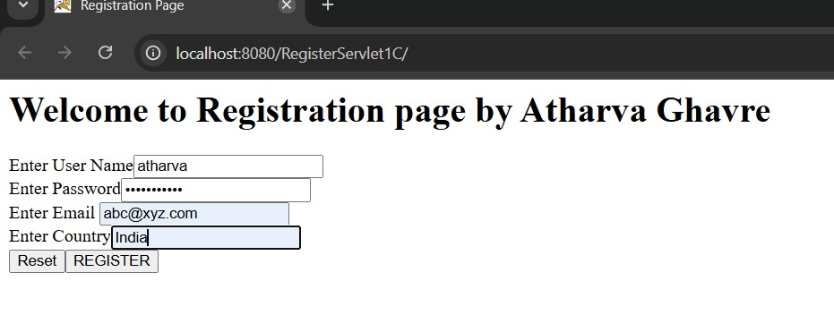
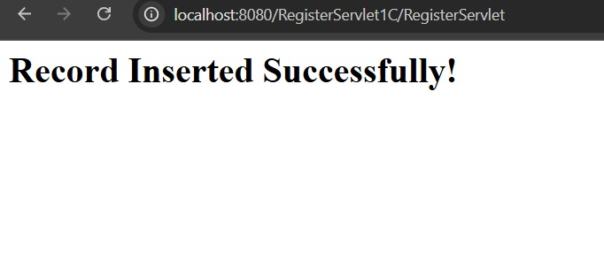
OUTPUT:
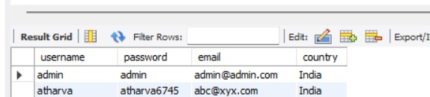
2A. Using Request Dispatcher Interface create a Servlet which will validate the password entered by the user, if the user has entered “Servlet” as password, then he will be forwarded to Welcome Servlet else the user will stay on the index.html page and an error message will be displayed.

Index.html
<!DOCTYPE html>
<html>
<head>
<title>Login Form</title>
</head>
<body>

<form action=”LoginServlet” method=”get”>
<div>
<h2>Atharva Ghavre</h2>
<label for=”txtId”>Enter User ID</label>
<input type=”text” id=”txtId” name=”txtId”>
</div>

<div>
<label for=”txtPass”>Enter Password</label>
<input type=”password” id=”txtPass” name=”txtPass”>
</div>

<input type=”reset” value=”Clear”>
<input type=”submit” value=”Login”>
</form>

</body>
</html>

LoginServlet.java
Import jakarta.servlet.RequestDispatcher;
Import jakarta.servlet.ServletException;
Import jakarta.servlet.annotation.WebServlet;
Import jakarta.servlet.http.HttpServlet;
Import jakarta.servlet.http.HttpServletRequest;
Import jakarta.servlet.http.HttpServletResponse;
Import java.io.IOException;
Import java.io.PrintWriter;

@WebServlet(“/LoginServlet”)
Public class LoginServlet extends HttpServlet {
@Override
Protected void doPost(HttpServletRequest request, HttpServletResponse response)
Throws ServletException, IOException {
processRequest(request, response);
}

@Override
Protected void doGet(HttpServletRequest request, HttpServletResponse response)
Throws ServletException, IOException {
processRequest(request, response);
}

Private void processRequest(HttpServletRequest request, HttpServletResponse response)
Throws ServletException, IOException {

Response.setContentType(“text/html;charset=UTF-8”);
PrintWriter out = response.getWriter();

String uname = request.getParameter(“txtId”); // fix: txtId (not txtld)
String upass = request.getParameter(“txtPass”);

If (“admin”.equals(uname) && “servlet”.equals(upass)) {
RequestDispatcher rd = request.getRequestDispatcher(“WelcomeServlet”);
Rd.forward(request, response);
} else {
Out.println(“<body bgcolor=’red’>”);
Out.println(“<h1>Login Failed !!!</h1>”);
RequestDispatcher rd = request.getRequestDispatcher(“index.html”);
Rd.include(request, response);
Out.println(“</body>”);
}
}
}

WelcomeServlet.java
Import jakarta.servlet.ServletException;
Import jakarta.servlet.annotation.WebServlet;
Import jakarta.servlet.http.HttpServlet;
Import jakarta.servlet.http.HttpServletRequest;
Import jakarta.servlet.http.HttpServletResponse;
Import java.io.*;

@WebServlet(“/WelcomeServlet”)
Public class WelcomeServlet extends HttpServlet {

@Override
Public void doGet(HttpServletRequest request, HttpServletResponse response)
Throws ServletException, IOException {

Response.setContentType(“text/html;charset=UTF-8”);
PrintWriter out = response.getWriter();

Out.println(“<html><head>”);
Out.println(“<title>Welcome</title></head>”);
Out.println(“<body bgcolor=lightgreen>”);
Out.println(“<h1> Welcome Atharva ! Login Successful ✅ </h1>”);
Out.println(“</body></html>”);
}
}

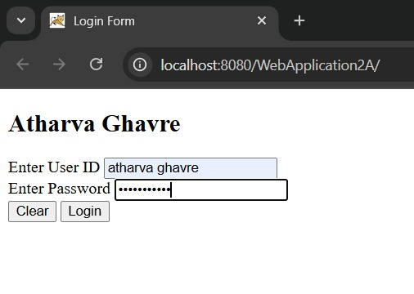
OUTPUT:
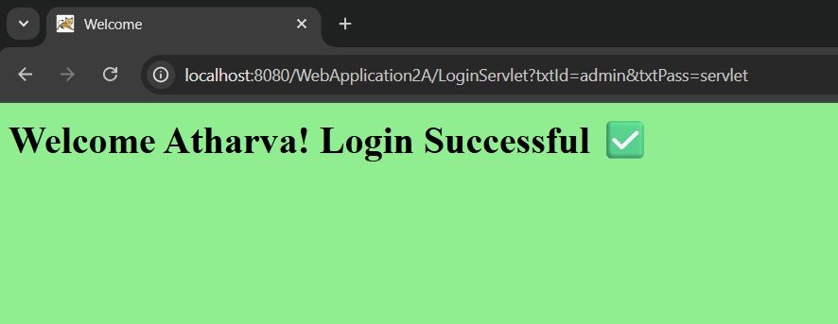

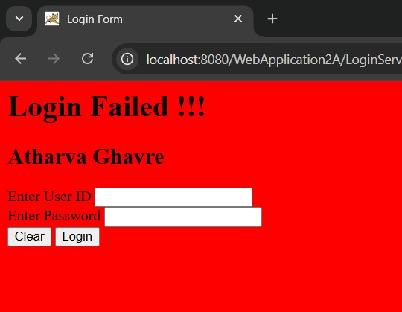

2B. Create a Servlet that uses Cookies to store the number of times a user has visited Servlet.

Index.html
<html>
<head>
<title>Cookie Demo</title>
</head>
<body>
<form action=”Page1” method=”get”>
Enter Your Name <input type=”text” name=”txtName”><br>
<input type=”submit” value=”~~~ Click to Enter ~~~”>
</form>
</body>
</html>

Page1.java
Import jakarta.servlet.ServletException;
Import jakarta.servlet.annotation.WebServlet;
Import jakarta.servlet.http.Cookie;
Import jakarta.servlet.http.HttpServlet;
Import jakarta.servlet.http.HttpServletRequest;
Import jakarta.servlet.http.HttpServletResponse;
Import java.io.*;
Import java.net.URLEncoder;

@WebServlet(“/Page1”)
Public class Page1 extends HttpServlet {

@Override
Public void doGet(HttpServletRequest request, HttpServletResponse response)
Throws ServletException, IOException {

Response.setContentType(“text/html;charset=UTF-8”);
PrintWriter out = response.getWriter();

String uname = request.getParameter(“txtName”);

String encodedName = URLEncoder.encode(uname, “UTF-8”);

// If username not provided, use default
If (uname == null || uname.trim().isEmpty()) {
Uname = “Guest”;
}

// Create cookies
Cookie ck1 = new Cookie(“username”, encodedName );
Cookie ck2 = new Cookie(“visit”, “1”);
Response.addCookie(ck1);
Response.addCookie(ck2);

// HTML output
Out.println(“<html>”);
Out.println(“<head><title>Page1</title></head>”);
Out.println(“<body bgcolor=’pink’>”);
Out.println(“<h1>~~~ Welcome “ + uname + “ ~~~</h1>”);
Out.println(“<h1><a href=’Page2’>Click to visit Page 2</a></h1>”);
Out.println(“</body>”);
Out.println(“</html>”);
}
}

Page2.html
Import jakarta.servlet.ServletException;
Import jakarta.servlet.annotation.WebServlet;
Import jakarta.servlet.http.Cookie;
Import jakarta.servlet.http.HttpServlet;
Import jakarta.servlet.http.HttpServletRequest;
Import jakarta.servlet.http.HttpServletResponse;
Import java.io.*;
Import java.net.URLDecoder;

@WebServlet(“/Page2”)
Public class Page2 extends HttpServlet {

Public void doGet(HttpServletRequest request, HttpServletResponse response)
Throws ServletException, IOException {

Response.setContentType(“text/html;charset=UTF-8”);
PrintWriter out = response.getWriter();

Out.println(“<html><head><title>Page2</title></head>”);
Out.println(“<body bgcolor=yellow>”);

Cookie[] ck = request.getCookies();
If (ck != null) {
For (int I = 0; I < ck.length; i++) {
If (ck[i].getName().equals(“visit”)) {
Int count = Integer.parseInt(ck[i].getValue()) + 1;
Out.println(“<h1>Visit No: “ + count + “</h1>”);
Ck[i] = new Cookie(“visit”, count + “”);
Response.addCookie(ck[i]);
} else if (ck[i].getName().equals(“username”)) {
String decodedName = URLDecoder.decode(ck[i].getValue(), “UTF-8”);
Out.println(“<h2>User: “ + decodedName + “</h2>”);
}
}
}

Out.println(“<h1><a href=Page3>Click to visit Page 3</a></h1>”);
Out.println(“<h1><a href=Page4>Click to visit Page 4</a></h1>”);
Out.println(“<h1><a href=Page5>Click to visit Page 5</a></h1>”);

Out.println(“</body></html>”);
}
}

Page3.html
Import jakarta.servlet.ServletException;
Import jakarta.servlet.annotation.WebServlet;
Import jakarta.servlet.http.Cookie;
Import jakarta.servlet.http.HttpServlet;
Import jakarta.servlet.http.HttpServletRequest;
Import jakarta.servlet.http.HttpServletResponse;
Import java.io.*;
Import java.net.URLDecoder;

@WebServlet(“/Page3”)
Public class Page3 extends HttpServlet {

Public void doGet(HttpServletRequest request, HttpServletResponse response)
Throws ServletException, IOException {

Response.setContentType(“text/html;charset=UTF-8”);
PrintWriter out = response.getWriter();

Out.println(“<html><head><title>Page3</title></head>”);
Out.println(“<body bgcolor=lightgreen>”);

Cookie[] ck = request.getCookies();
If (ck != null) {
For (int I = 0; I < ck.length; i++) {
If (ck[i].getName().equals(“visit”)) {
Int count = Integer.parseInt(ck[i].getValue()) + 1;
Out.println(“<h1>Visit No: “ + count + “</h1>”);
Ck[i] = new Cookie(“visit”, count + “”);
Response.addCookie(ck[i]);
} else if (ck[i].getName().equals(“username”)) {
String decodedName = URLDecoder.decode(ck[i].getValue(), “UTF-8”);
Out.println(“<h2>User: “ + decodedName + “</h2>”);
}
}
}

Out.println(“<h1><a href=Page4>Click to visit Page 4</a></h1>”);
Out.println(“<h1><a href=Page5>Click to visit Page 5</a></h1>”);
Out.println(“<h1><a href=Page1>Back to Page 1</a></h1>”);

out.println("</body></html>");
}
}

Page4.html
Import java.io.IOException;
Import java.io.PrintWriter;
Import jakarta.servlet.ServletException;
Import jakarta.servlet.annotation.WebServlet;
Import jakarta.servlet.http.Cookie;
Import jakarta.servlet.http.HttpServlet;
Import jakarta.servlet.http.HttpServletRequest;
Import jakarta.servlet.http.HttpServletResponse;
Import java.net.URLDecoder;

@WebServlet(“/Page4”)
Public class Page4 extends HttpServlet {

Public void doGet(HttpServletRequest request, HttpServletResponse response)
Throws ServletException, IOException {

Response.setContentType(“text/html;charset=UTF-8”);
PrintWriter out = response.getWriter();

Out.println(“<html><head><title>Page4</title></head>”);
Out.println(“<body bgcolor=orange>”);

Cookie[] ck = request.getCookies();
If (ck != null) {
For (int I = 0; I < ck.length; i++) {
If (ck[i].getName().equals(“visit”)) {
Int count = Integer.parseInt(ck[i].getValue()) + 1;
Out.println(“<h1>Visit No: “ + count + “</h1>”);
Ck[i] = new Cookie(“visit”, count + “”);
Response.addCookie(ck[i]);
} else if (ck[i].getName().equals(“username”)) {
String decodedName = URLDecoder.decode(ck[i].getValue(), “UTF-8”);
Out.println(“<h2>User: “ + decodedName + “</h2>”);
}
}
}

Out.println(“<h1><a href=Page5>Click to visit Page 5</a></h1>”);
Out.println(“<h1><a href=Page1>Back to Page 1</a></h1>”);

Out.println(“</body></html>”);
}
}

Page5.html
Import java.io.IOException;
Import java.io.PrintWriter;
Import jakarta.servlet.ServletException;
Import jakarta.servlet.annotation.WebServlet;
Import jakarta.servlet.http.Cookie;
Import jakarta.servlet.http.HttpServlet;
Import jakarta.servlet.http.HttpServletRequest;
Import jakarta.servlet.http.HttpServletResponse;
Import java.net.URLDecoder;

@WebServlet(“/Page5”)
Public class Page5 extends HttpServlet {

Public void doGet(HttpServletRequest request, HttpServletResponse response)
Throws ServletException, IOException {

Response.setContentType(“text/html;charset=UTF-8”);
PrintWriter out = response.getWriter();

Out.println(“<html><head><title>Page5</title></head>”);
Out.println(“<body bgcolor=lightblue>”);

Cookie[] ck = request.getCookies();
If (ck != null) {
For (int I = 0; I < ck.length; i++) {
If (ck[i].getName().equals(“visit”)) {
Int count = Integer.parseInt(ck[i].getValue()) + 1;
Out.println(“<h1>Visit No: “ + count + “</h1>”);
Ck[i] = new Cookie(“visit”, count + “”);
Response.addCookie(ck[i]);
} else if (ck[i].getName().equals(“username”)) {
String decodedName = URLDecoder.decode(ck[i].getValue(), “UTF-8”);
Out.println(“<h2>User: “ + decodedName + “</h2>”);
}
}
}

Out.println(“<h1><a href=Page1>Back to Page 1</a></h1>”);
Out.println(“<h1><a href=Page2>Back to Page 2</a></h1>”);

Out.println(“</body></html>”);
}
}

OUTPUT:
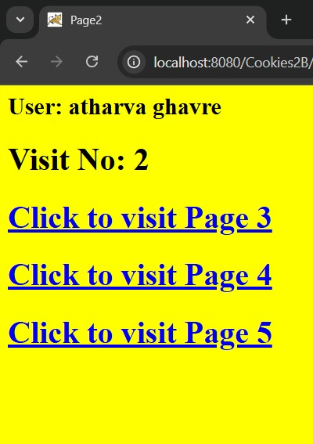
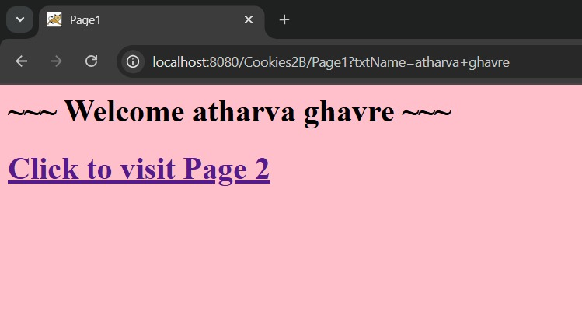
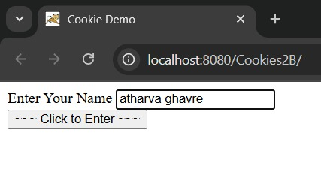

2c. Create a Servlet demonstrating the use of session creation and destruction. Also check whether the user has visited this page first time or has visited earlier also using Sessions.

Index.html
<!DOCTYPE html>
<html>
<head>
<title>Session Demo</title>
</head>
<body bgcolor=”lightgrey”>
<h1>Session Tracking Demo</h1>
<form action=”Page1” method=”get”>
Enter User ID: <input type=”text” name=”txtName” required><br><br>
<input type=”reset” value=”Reset”>
<input type=”submit” value=”Submit”>
</form>
</body>
</html>

Logout Servlet.java

Import java.io.*;
Import jakarta.servlet.*;
Import jakarta.servlet.annotation.WebServlet;
Import jakarta.servlet.http.*;

@WebServlet(“/LogoutServlet”)
Public class LogoutServlet extends HttpServlet {

Public void doGet(HttpServletRequest request, HttpServletResponse response)
Throws ServletException, IOException {

Response.setContentType(“text/html;charset=UTF-8”);
PrintWriter out = response.getWriter();

Out.println(“<html><head><title>Logout</title></head>”);
Out.println(“<body bgcolor=lightgrey>”);

// Get the session; if exists, invalidate
HttpSession hs = request.getSession(false);
If (hs != null) {
Hs.invalidate();
}

Out.println(“<h1>You are logged out successfully.</h1>”);
Out.println(“<h2><a href=index.html>Go back to Login Page</a></h2>”);

Out.println(“</body></html>”);
}
}

Page1.java
Import java.io.*;
Import jakarta.servlet.*;
Import jakarta.servlet.annotation.WebServlet;
Import jakarta.servlet.http.*;

@WebServlet(“/Page1”)
Public class Page1 extends HttpServlet {

Public void doGet(HttpServletRequest request, HttpServletResponse response)
Throws ServletException, IOException {

Response.setContentType(“text/html;charset=UTF-8”);
PrintWriter out = response.getWriter();

Out.println(“<html><head><title>Servlet Page1</title></head>”);
Out.println(“<body bgcolor=yellow>”);

HttpSession hs = request.getSession(true);

If (hs.isNew()) {
String name = request.getParameter(“txtName”);
Hs.setAttribute(“uname”, name);
Hs.setAttribute(“visit”, “1”);

Out.println(“<h1>Welcome First Time, “ + name + “</h1>”);
} else {
Out.println(“<h1>Welcome Again</h1>”);
Int visit = Integer.parseInt((String) hs.getAttribute(“visit”)) + 1;
Hs.setAttribute(“visit”, String.valueOf(visit));
Out.println(“<h1>You Visited “ + visit + “ Times</h1>”);
}

Out.println(“<h2><a href=Page2>Go to Page 2</a></h2>”);
Out.println(“<h2><a href=LogoutServlet>Terminate Session</a></h2>”);
Out.println(“</body></html>”);
}
}

Page2.java

Import java.io.*;
Import jakarta.servlet.*;
Import jakarta.servlet.annotation.WebServlet;
Import jakarta.servlet.http.*;

@WebServlet(“/Page2”)
Public class Page2 extends HttpServlet {

Public void doGet(HttpServletRequest request, HttpServletResponse response)
Throws ServletException, IOException {

Response.setContentType(“text/html;charset=UTF-8”);
PrintWriter out = response.getWriter();

Out.println(“<html><head><title>Servlet Page2</title></head>”);
Out.println(“<body bgcolor=lightblue>”);

HttpSession hs = request.getSession(false);

If (hs == null) {
Out.println(“<h1>No active session. Please <a href=index.html>login again</a>.</h1>”);
} else {
Int visit = Integer.parseInt((String) hs.getAttribute(“visit”)) + 1;
Hs.setAttribute(“visit”, String.valueOf(visit));

Out.println(“<h1>Welcome first time</h1>”);
Out.println(“<h1>You Visited “ + visit + “ Times</h1>”);
Out.println(“<h1>Your Session ID: “ + hs.getId() + “</h1>”);
Out.println(“<h1>You Logged in at: “ + new java.util.Date(hs.getCreationTime()) + “</h1>”);
}

Out.println(“<h2><a href=Page1>Go to Page 2</a></h2>”);
Out.println(“<h2><a href=Page3>Go to Page 3</a></h2>”);
Out.println(“<h2><a href=Page4>Go to Page 4</a></h2>”);
Out.println(“<h2><a href=LogoutServlet>Terminate Session</a></h2>”);

Out.println(“</body></html>”);
}
}

Page3.java
import java.io.*;
import jakarta.servlet.*;
import jakarta.servlet.annotation.WebServlet;
import jakarta.servlet.http.*;
@WebServlet("/Page3")
public class Page3 extends HttpServlet {

public void doGet(HttpServletRequest request, HttpServletResponse response)
throws ServletException, IOException {

response.setContentType("text/html;charset=UTF-8");
PrintWriter out = response.getWriter();

out.println("<html><head><title>Servlet Page3</title></head>");
out.println("<body bgcolor=lightgreen>");

HttpSession hs = request.getSession(false);

if (hs == null) {
out.println("<h1>No active session. Please <a href=index.html>login again</a>.</h1>");
} else {
int visit = Integer.parseInt((String) hs.getAttribute("visit")) + 1;
hs.setAttribute("visit", String.valueOf(visit));
String uname = (String) hs.getAttribute("uname");

out.println("<h1>Welcome " + uname + " to Page 3</h1>");
out.println("<h1>You Visited " + visit + " Times</h1>");
out.println("<h1>Session ID: " + hs.getId() + "</h1>");
}

out.println("<h2><a href=Page1>Go to Page 1</a></h2>");
out.println("<h2><a href=Page2>Go to Page 2</a></h2>");
out.println("<h2><a href=Page4>Go to Page 4</a></h2>");
out.println("<h2><a href=Page5>Go to Page 5</a></h2>");
out.println("<h2><a href=LogoutServlet>Terminate Session</a></h2>");

out.println("</body></html>");
}
}

Page4.java
Import java.io.*;
Import jakarta.servlet.*;
Import jakarta.servlet.annotation.WebServlet;
Import jakarta.servlet.http.*;

@WebServlet(“/Page4”)
Public class Page4 extends HttpServlet {

Public void doGet(HttpServletRequest request, HttpServletResponse response)
Throws ServletException, IOException {

Response.setContentType(“text/html;charset=UTF-8”);
PrintWriter out = response.getWriter();

Out.println(“<html><head><title>Servlet Page4</title></head>”);
Out.println(“<body bgcolor=orange>”);

HttpSession hs = request.getSession(false);

If (hs == null) {
Out.println(“<h1>No active session. Please <a href=index.html>login again</a>.</h1>”);
} else {
Int visit = Integer.parseInt((String) hs.getAttribute(“visit”)) + 1;
Hs.setAttribute(“visit”, String.valueOf(visit));
String uname = (String) hs.getAttribute(“uname”);

Out.println(“<h1>Welcome “ + uname + “ to Page 4</h1>”);
Out.println(“<h1>You Visited “ + visit + “ Times</h1>”);
Out.println(“<h1>Session ID: “ + hs.getId() + “</h1>”);
}

Out.println(“<h2><a href=Page1>Go to Page 1</a></h2>”);
Out.println(“<h2><a href=Page2>Go to Page 2</a></h2>”);
Out.println(“<h2><a href=Page3>Go to Page 3</a></h2>”);
Out.println(“<h2><a href=Page5>Go to Page 5</a></h2>”);
Out.println(“<h2><a href=LogoutServlet>Terminate Session</a></h2>”);

Out.println(“</body></html>”);
}
}

Page5.java
Import java.io.*;
Import jakarta.servlet.*;
Import jakarta.servlet.annotation.WebServlet;
Import jakarta.servlet.http.*;

@WebServlet(“/Page5”)
Public class Page5 extends HttpServlet {

Public void doGet(HttpServletRequest request, HttpServletResponse response)
Throws ServletException, IOException {

Response.setContentType(“text/html;charset=UTF-8”);
PrintWriter out = response.getWriter();

Out.println(“<html><head><title>Servlet Page5</title></head>”);
Out.println(“<body bgcolor=lightblue>”);

HttpSession hs = request.getSession(false);

If (hs == null) {
Out.println(“<h1>No active session. Please <a href=index.html>login again</a>.</h1>”);
} else {
Int visit = Integer.parseInt((String) hs.getAttribute(“visit”)) + 1;
Hs.setAttribute(“visit”, String.valueOf(visit));
String uname = (String) hs.getAttribute(“uname”);

Out.println(“<h1>Welcome “ + uname + “ to Page 5</h1>”);
Out.println(“<h1>You Visited “ + visit + “ Times</h1>”);
Out.println(“<h1>Session ID: “ + hs.getId() + “</h1>”);
}

Out.println(“<h2><a href=Page1>Go to Page 1</a></h2>”);
Out.println(“<h2><a href=Page2>Go to Page 2</a></h2>”);
Out.println(“<h2><a href=Page3>Go to Page 3</a></h2>”);
Out.println(“<h2><a href=Page4>Go to Page 4</a></h2>”);
Out.println(“<h2><a href=LogoutServlet>Terminate Session</a></h2>”);
Out.println(“</body></html>”);
}
}
OUTPUT:
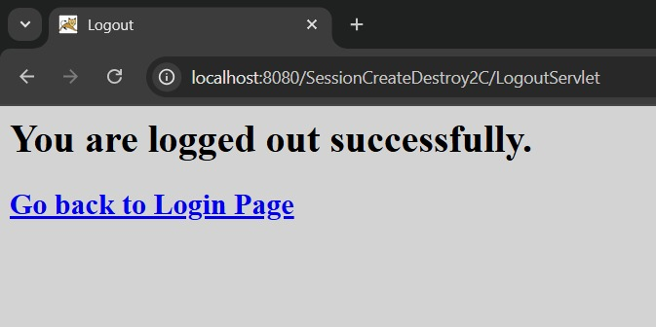
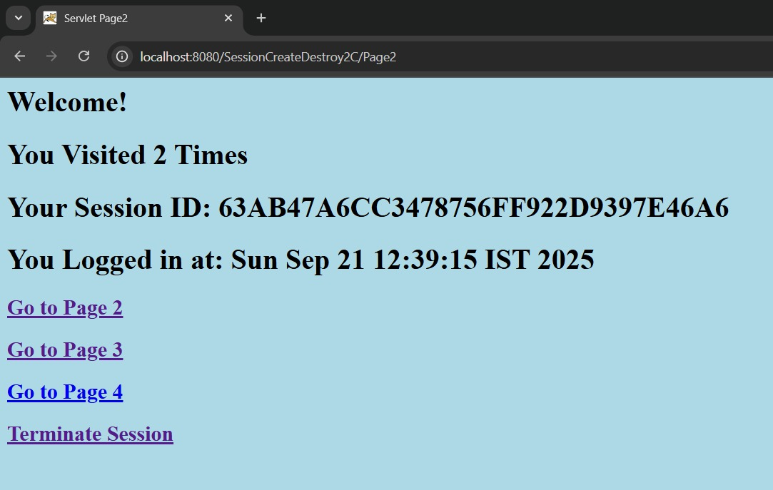
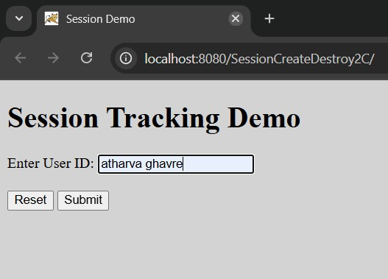

3B. Develop Simple Servlet Question Answer Application using Database.

Index.html
<!DOCTYPE html>
<html lang=”en”>
<head>
<meta charset=”UTF-8”>
<title>Quiz Application</title>
<style>
Body {
Font-family: Arial, sans-serif;
Text-align: center;
Margin-top: 100px;
}
H1 {
Color: #333;
}
A {
Display: inline-block;
Padding: 12px 24px;
Background-color: #007BFF;
Color: white;
Text-decoration: none;
Font-size: 18px;
Border-radius: 6px;
}
A:hover {
Background-color: #0056b3;
}
</style>
</head>
<body>
<h1>Welcome to Quiz Servlet by Atharva Ghavre</h1>
<a href=”QuizServlet”>CLICK TO START QUIZ</a>
</body>
</html>

QuizServlet.java
Import jakarta.servlet.ServletException;
Import jakarta.servlet.annotation.WebServlet;
Import jakarta.servlet.http.HttpServlet;
Import jakarta.servlet.http.HttpServletRequest;
Import jakarta.servlet.http.HttpServletResponse;

Import java.io.*;
Import java.sql.*;

@WebServlet(“/QuizServlet”)
Public class QuizServlet extends HttpServlet {

@Override
Public void doGet(HttpServletRequest request, HttpServletResponse response)
Throws ServletException, IOException {

Response.setContentType(“text/html;charset=UTF-8”);
PrintWriter out = response.getWriter();

Out.println(“<form action=’ShowResult’>”);

Try {
// Load MySQL Driver
Class.forName(“com.mysql.cj.jdbc.Driver”);

// Connect to Database
Connection con = DriverManager.getConnection(
“jdbc:mysql://localhost:3306/qadb”, “root”, “atharva6745”);

Statement stmt = con.createStatement();
ResultSet res = stmt.executeQuery(“SELECT * FROM quiz”);

Out.println(“<table border=’1’ cellpadding=’10’>”);

Int qno = 0;
While (res.next()) {
Qno++;

// Question
Out.println(“<tr><td colspan=’2’><b>Q” + qno + “. “ + res.getString(“question”) + “</b></td></tr>”);

// Options
Out.println(“<tr><td><input type=’radio’ name=’” + qno + “’ value=’”
+ res.getString(“op1”) + “’></td><td>” + res.getString(“op1”) + “</td></tr>”);

Out.println(“<tr><td><input type=’radio’ name=’” + qno + “’ value=’”
+ res.getString(“op2”) + “’></td><td>” + res.getString(“op2”) + “</td></tr>”);

Out.println(“<tr><td><input type=’radio’ name=’” + qno + “’ value=’”
+ res.getString(“op3”) + “’></td><td>” + res.getString(“op3”) + “</td></tr>”);

Out.println(“<tr><td><input type=’radio’ name=’” + qno + “’ value=’”
+ res.getString(“op4”) + “’></td><td>” + res.getString(“op4”) + “</td></tr>”);
}

Out.println(“</table>”);
Out.println(“<br><input type=’reset’>”);
Out.println(“<input type=’submit’ value=’SUBMIT’>”);

Stmt.close();
Con.close();

} catch (Exception e) {
Out.println(“<h1>Error: “ + e.getMessage() + “</h1>”);
}

Out.println(“</form>”);
}
}

ShowResult.java

Import jakarta.servlet.ServletException;
Import jakarta.servlet.annotation.WebServlet;
Import jakarta.servlet.http.HttpServlet;
Import jakarta.servlet.http.HttpServletRequest;
Import jakarta.servlet.http.HttpServletResponse;

Import java.io.*;
Import java.sql.*;

@WebServlet(“/QuizServlet”)
Public class QuizServlet extends HttpServlet {

@Override
Public void doGet(HttpServletRequest request, HttpServletResponse response)
Throws ServletException, IOException {

Response.setContentType(“text/html;charset=UTF-8”);
PrintWriter out = response.getWriter();

Out.println(“<form action=’ShowResult’>”);

Try {
// Load MySQL Driver
Class.forName(“com.mysql.cj.jdbc.Driver”);

// Connect to Database
Connection con = DriverManager.getConnection(
“jdbc:mysql://localhost:3306/qadb”, “root”, “atharva6745”);

Statement stmt = con.createStatement();
ResultSet res = stmt.executeQuery(“SELECT * FROM quiz”);

Out.println(“<table border=’1’ cellpadding=’10’>”);

Int qno = 0;
While (res.next()) {
Qno++;

// Question
Out.println(“<tr><td colspan=’2’><b>Q” + qno + “. “ + res.getString(“question”) + “</b></td></tr>”);

// Options
Out.println(“<tr><td><input type=’radio’ name=’” + qno + “’ value=’”
+ res.getString(“op1”) + “’></td><td>” + res.getString(“op1”) + “</td></tr>”);

Out.println(“<tr><td><input type=’radio’ name=’” + qno + “’ value=’”
+ res.getString(“op2”) + “’></td><td>” + res.getString(“op2”) + “</td></tr>”);

Out.println(“<tr><td><input type=’radio’ name=’” + qno + “’ value=’”
+ res.getString(“op3”) + “’></td><td>” + res.getString(“op3”) + “</td></tr>”);

Out.println(“<tr><td><input type=’radio’ name=’” + qno + “’ value=’”
+ res.getString(“op4”) + “’></td><td>” + res.getString(“op4”) + “</td></tr>”);
}

Out.println(“</table>”);
Out.println(“<br><input type=’reset’>”);
Out.println(“<input type=’submit’ value=’SUBMIT’>”);

Stmt.close();
Con.close();

} catch (Exception e) {
Out.println(“<h1>Error: “ + e.getMessage() + “</h1>”);
}
Out.println(“</form>”)

Sql

- Create database
CREATE DATABASE qadb;
Select database
USE qadb;
Create table
CREATE TABLE quiz (
Qno VARCHAR(5) PRIMARY KEY,
Question VARCHAR(150),
Op1 VARCHAR(50),
Op2 VARCHAR(50),
Op3 VARCHAR(50),
Op4 VARCHAR(50),
Ans VARCHAR(50)
);
Insert quiz questions
INSERT INTO quiz VALUES
(‘001’, ‘What is the capital of India?’, ‘New Delhi’, ‘Kolkata’, ‘Chennai’, ‘Mumbai’, ‘New Delhi’),
(‘002’, ‘Who was the First President of India?’, ‘Dr. Rajendra Prasad’, ‘Dr. S. Radhakrishnan’, ‘Ram Nath Kovind’, ‘V. V. Giri’, ‘Dr. Rajendra Prasad’),
(‘003’, ‘What is ORM?’, ‘Object Ratio Mean’, ‘Object Rotation Measure’, ‘Object Relation Mapping’, ‘Oracle Management’, ‘Object Relation Mapping’),
(‘004’, ‘The unit of Energy is __’, ‘Dozen’, ‘Kilometer’, ‘Joule’, ‘Hertz’, ‘Joule’),
(‘005’, ‘____ is the smallest memory unit.’, ‘Bit’, ‘Byte’, ‘Kilobyte’, ‘Gigabyte’,’Bit’);

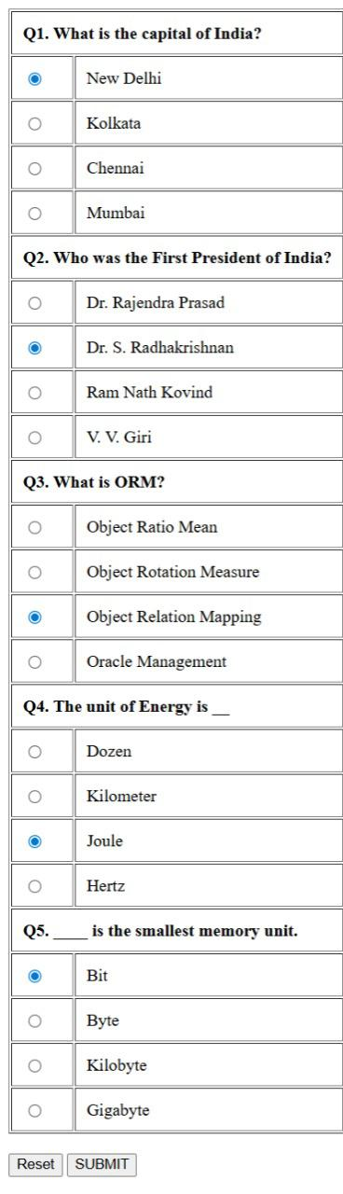
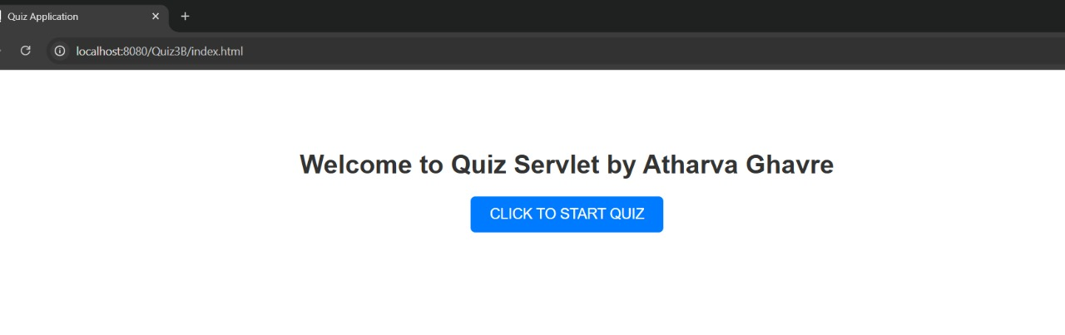
OUTPUT:
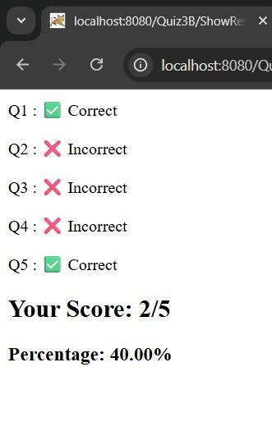

4b. Develop a simple JSP application to pass values from one page to another with validations.

Index.html
import jakarta.servlet.ServletException;
import jakarta.servlet.annotation.WebServlet;
import jakarta.servlet.http.HttpServlet;
import jakarta.servlet.http.HttpServletRequest;
import jakarta.servlet.http.HttpServletResponse;

import java.io.*;
import java.sql.*;

@WebServlet("/ShowResult")
public class ShowResult extends HttpServlet {

@Override
public void doGet(HttpServletRequest request, HttpServletResponse response)
throws ServletException, IOException {

response.setContentType("text/html;charset=UTF-8");
PrintWriter out = response.getWriter();

try {
// Load MySQL Driver
Class.forName("com.mysql.cj.jdbc.Driver");

// Connect to Database
Connection con = DriverManager.getConnection(
"jdbc:mysql://localhost:3306/qadb", "root", "atharva6745");

Statement stmt = con.createStatement();
ResultSet res = stmt.executeQuery("SELECT ans FROM quiz");

int count = 0, qno = 0;
int total = 0;

while (res.next()) {
total++;
qno++;

String correctAns = res.getString(1);
String userAns = request.getParameter(String.valueOf(qno));

if (correctAns != null && correctAns.equals(userAns)) {
count++;
out.println("<p>Q" + qno + " : ✅ Correct</p>");
} else {
out.println("<p>Q" + qno + " : ❌ Incorrect</p>");
}
}

double percentage = (total > 0) ? (count * 100.0 / total) : 0;

out.println("<h2>Your Score: " + count + "/" + total + "</h2>");
out.println("<h3>Percentage: " + String.format("%.2f", percentage) + "%</h3>");

stmt.close();
con.close();

} catch (Exception e) {
out.println("<h1>Error: " + e.getMessage() + "</h1>");
}
}
}

Validate.jsp

<%@ page contentType=”text/html;charset=UTF-8” import=”mypack.*” %>
<html>
<head><title>Validation Page</title></head>

<h1>Validation Page</h1>

<jsp:useBean id=”obj” class=”mypack.CheckerBean” scope=”request”>
<jsp:setProperty name=”obj” property=”*”/>
</jsp:useBean>

<%
If(obj.validate()) {
%>
<jsp:forward page=”successful.jsp”/>
<%
} else {
%>
<p style=”color:red;”><%= obj.getError() %></p>
<jsp:include page=”index.html”/>
<%
}
%>

</html>

CheckerBean.java
package mypack;
public class CheckerBean {
private String name, age, hob, email, gender;
private String error;

public CheckerBean() {
error = "";
}

public void setName(String n) { name = n; }
public void setAge(String a) { age = a; }
public void setHob(String h) { hob = h; }
public void setEmail(String e) { email = e; }
public void setGender(String g) { gender = g; }
public void setError(String e) { error = e; }

public String getName() { return name; }
public String getAge() { return age; }
public String getHob() { return hob; }
public String getEmail() { return email; }
public String getGender() { return gender; }
public String getError() { return error; }

public boolean validate() {
boolean res = true;
if (name == null || name.trim().isEmpty()) {
error += "<br>Enter Name";
res = false;
}
if (age == null || !age.matches("\\d{1,2}")) {
error += "<br>Enter valid Age (1-99)";
res = false;
}
if (email == null || !email.contains("@")) {
error += "<br>Enter valid Email";
res = false;
}
if (gender == null || gender.isEmpty()) {
error += "<br>Select Gender";
res = false;
}
return res;
}
}
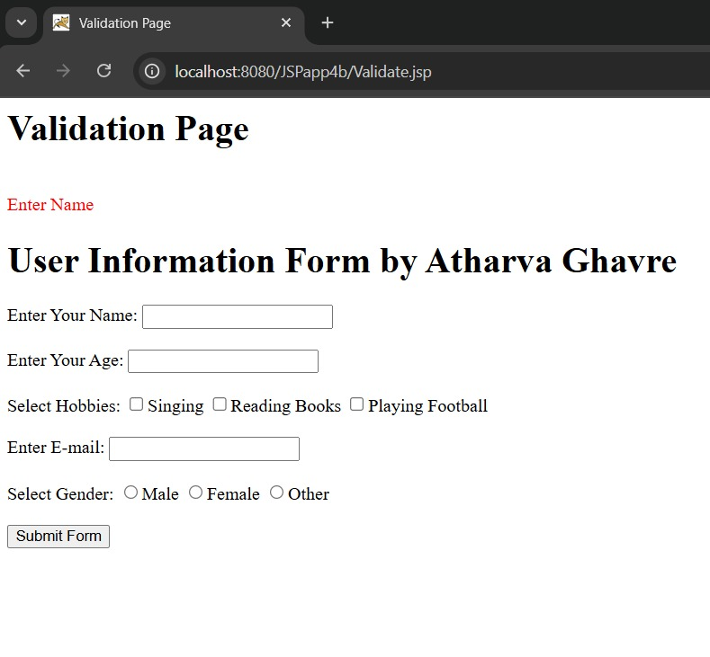
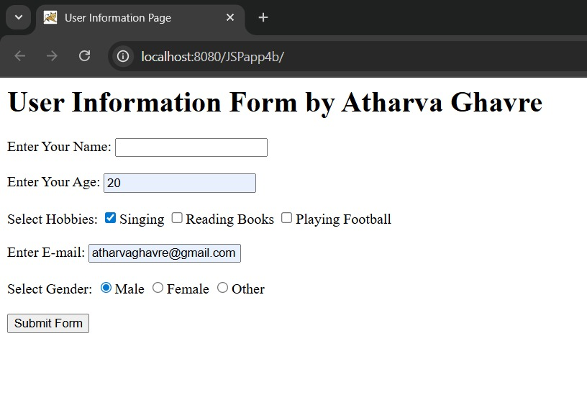
OUTPUT:

4c. Create a registration and login JSP application to register and authenticate the user based on username and password using JDBC.

Index.html
<!DOCTYPE html>
<html>
<head>
<title>page1</title>
</head>
<body>
<h1>Atharva Ghavre</h1>
<h2><a href=”Register.html”>New user register here</a></h2>
<h2><a href=”Login.html”>Click here to login</a></h2>
</body>
</html>

Register.html
<html>
<head>
<title>New User Registration Page</title>
</head>
<body>
<h1>New User Registration Page</h1>
<form action=”Register.jsp” method=”post”>
Enter User Name: <input type=”text” name=”txtName” required><br><br>
Enter Password: <input type=”password” name=”txtPass1” required><br><br>
Re-Enter Password: <input type=”password” name=”txtPass2” required><br><br>
Enter Email: <input type=”email” name=”txtEmail” required><br><br>
Enter Country Name: <input type=”text” name=”txtCon”><br><br>
<input type=”reset” value=”Reset”>
<input type=”submit” value=”REGISTER”>
</form>
</body>
</html>

Register.jsp

<%@ page contentType=”text/html;charset=UTF-8” import=”java.sql.*” %>
<html>
<body>
<h1>Registration Page</h1>

<%
String uname = request.getParameter(“txtName”);
String pass1 = request.getParameter(“txtPass1”);
String pass2 = request.getParameter(“txtPass2”);
String email = request.getParameter(“txtEmail”);
String ctry = request.getParameter(“txtCon”);

If(pass1 != null && pass1.equals(pass2)) {
Connection con = null;
PreparedStatement stmt = null;
Try {
Class.forName(“com.mysql.cj.jdbc.Driver”);
Con = DriverManager.getConnection(
“jdbc:mysql://localhost:3306/logindb?useSSL=false&serverTimezone=UTC”,
“root”, “atharva6745”); // replace with your DB credentials

Stmt = con.prepareStatement(
“INSERT INTO user(username, password, email, country) VALUES (?,?,?,?)”);

Stmt.setString(1, uname);
Stmt.setString(2, pass1);
Stmt.setString(3, email);
Stmt.setString(4, ctry);

Int row = stmt.executeUpdate();
If(row == 1) {
Out.println(“<h2>Registration Successful!</h2>”);
} else {
Out.println(“<h2>Registration Failed!</h2>”);
%><jsp:include page=”index.html” /><%
}

} catch(Exception e) {
Out.println(“<h3>Error: “ + e.getMessage() + “</h3>”);
} finally {
If(stmt != null) stmt.close();
If(con != null) con.close();
}
} else {
Out.println(“<h2>Password Mismatch</h2>”);
%><jsp:include page=”Register.html” /><%
}
%>
</body>
</html>

Login.html
<html>
<body>
<h1>Login Page</h1>
<form action=”Login.jsp” method=”post”>
Enter User Name: <input type=”text” name=”txtName” required><br><br>
Enter Password: <input type=”password” name=”txtPass” required><br><br>
<input type=”reset” value=”Reset”>
<input type=”submit” value=”LOGIN”>
</form>
</body>
</html>

Login.jsp
<%@ page contentType=”text/html;charset=UTF-8” import=”java.sql.*” %>
<html>
<body>
<h1>Login Page</h1>

<%
String uname = request.getParameter(“txtName”);
String pass = request.getParameter(“txtPass”);

Connection con = null;
PreparedStatement stmt = null;
ResultSet rs = null;

Try {
Class.forName(“com.mysql.cj.jdbc.Driver”);
Con = DriverManager.getConnection(
“jdbc:mysql://localhost:3306/logindb?useSSL=false&serverTimezone=UTC”,
“root”, “atharva6745”); // replace with your DB credentials

Stmt = con.prepareStatement(
“SELECT password FROM user WHERE username=?”);
Stmt.setString(1, uname);

Rs = stmt.executeQuery();
If(rs.next()) {
String dbPass = rs.getString(“password”);
If(pass.equals(dbPass)) {
Out.println(“<h2>Login Successful!</h2>”);
} else {
Out.println(“<h2>Invalid Password!</h2>”);
%><jsp:include page=”Login.html” /><%
}
} else {
Out.println(“<h2>User does not exist!</h2>”);
%><jsp:include page=”Register.html” /><%
}

} catch(Exception e) {
Out.println(“<h3>Error: “ + e.getMessage() + “</h3>”);
} finally {
If(rs != null) rs.close();
If(stmt != null) stmt.close();
If(con != null) con.close();
}
%>

</body>
</html>

Sql
CREATE DATABASE logindb;

USE logindb;

CREATE TABLE user (
Username VARCHAR(50) NOT NULL PRIMARY KEY,
Password VARCHAR(255) NOT NULL,
Email VARCHAR(100) NOT NULL,
Country VARCHAR(50)
);

- Optional test user
INSERT INTO user (username, password, email, country)
VALUES (‘testuser’, ‘test123’, ‘test@example.com’,’India’);

OUTPUT:
